
Intrusion Detection System (IDS) Using Snort

Instructor: Sir Muhammad Jawad Khan
Group Members Name:
- Mahender Dev (71355)
- Muhammad Afnan Solangi (71328)
- Mahroof Ali (71384)
- Anis Ahmed Khan (70385)
Course: Network Security Lab
Submission Date: 6/20/2026

Abstract
This project demonstrates the implementation of a Network Intrusion Detection System (NIDS) using Snort. The system was designed in a virtual environment consisting of three machines: an attacker machine (Kali Linux), a victim server (Ubuntu Server), and a Snort IDS server (Ubuntu Server with Snort). The IDS monitors network traffic and generates alerts when suspicious activities such as network scanning, ICMP traffic, and SQL injection attempts are detected. The project highlights the importance of intrusion detection systems in identifying and responding to cyber threats in real-time.

Table of Contents
- Introduction
- Objectives
- Software and Hardware Requirements
- Network Topology
- Project Design
- Installation and Configuration
- Snort Rule Configuration
- Attack Simulation
- Results and Analysis
- Conclusion
- Future Enhancements
- References

1. Introduction
With the increasing number of cyberattacks, organizations require mechanisms to monitor and detect malicious activities within their networks. Intrusion Detection Systems (IDS) play a critical role in identifying suspicious network traffic and alerting administrators.
Snort is one of the most widely used open-source intrusion detection systems. It analyzes network packets and compares them against predefined rules to identify threats such as network scans, brute-force attacks, malware communication, and web-based attacks.
This project demonstrates the deployment and configuration of Snort in a virtualized network environment.

2. Objectives
The objectives of this project are:
- To install and configure Snort IDS.
- To create a virtual network environment.
- To monitor network traffic.
- To detect suspicious activities using custom Snort rules.
- To generate alerts for attack attempts.
- To understand the role of IDS in cybersecurity.

3. Software and Hardware Requirements

Hardware Requirements
- Intel Core i5/i7 Processor
- 8 GB RAM or higher
- 50 GB Free Disk Space

Software Requirements
Software |  |  | Purpose
VMware Workstation |  |  | Virtualization Platform
Kali Linux |  |  | Attacker Machine
Ubuntu Server |  |  | Victim Machine
Ubuntu Server |  |  | Snort IDS Server
Snort 2.9.15.1 |  |  | Intrusion Detection System
Nmap |  |  | Network Scanning Tool
Hydra |  |  | Brute Force Tool
Apache2 |  |  | Web Server

4. Network Topology

Network Configuration
Device | IP Address | Role
Kali Linux | 192.168.75.10 | Attacker
Ubuntu Server | 192.168.75.20 | Victim
Ubuntu Server + Snort | 192.168.75.30 | IDS
Subnet Mask:
255.255.255.0
Network:
192.168.75.0/24

Screenshot 1:
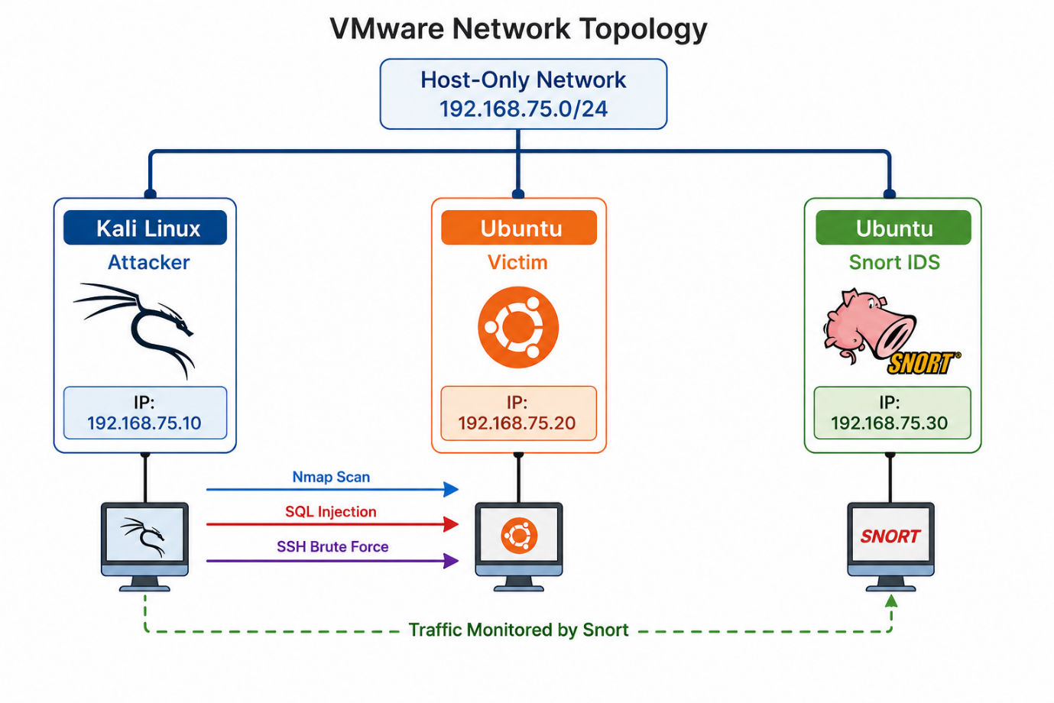

5. Project Design
The network consists of three virtual machines connected through VMware Host-Only Networking.
- Kali Linux acts as the attacker.
- Ubuntu Server acts as the target machine.
- Snort Server monitors and analyzes network traffic.
The attacker generates traffic using Nmap, Ping, and SQL Injection requests. Snort analyzes packets and generates alerts based on configured rules.

Screenshot 2: Virtual Machines Running
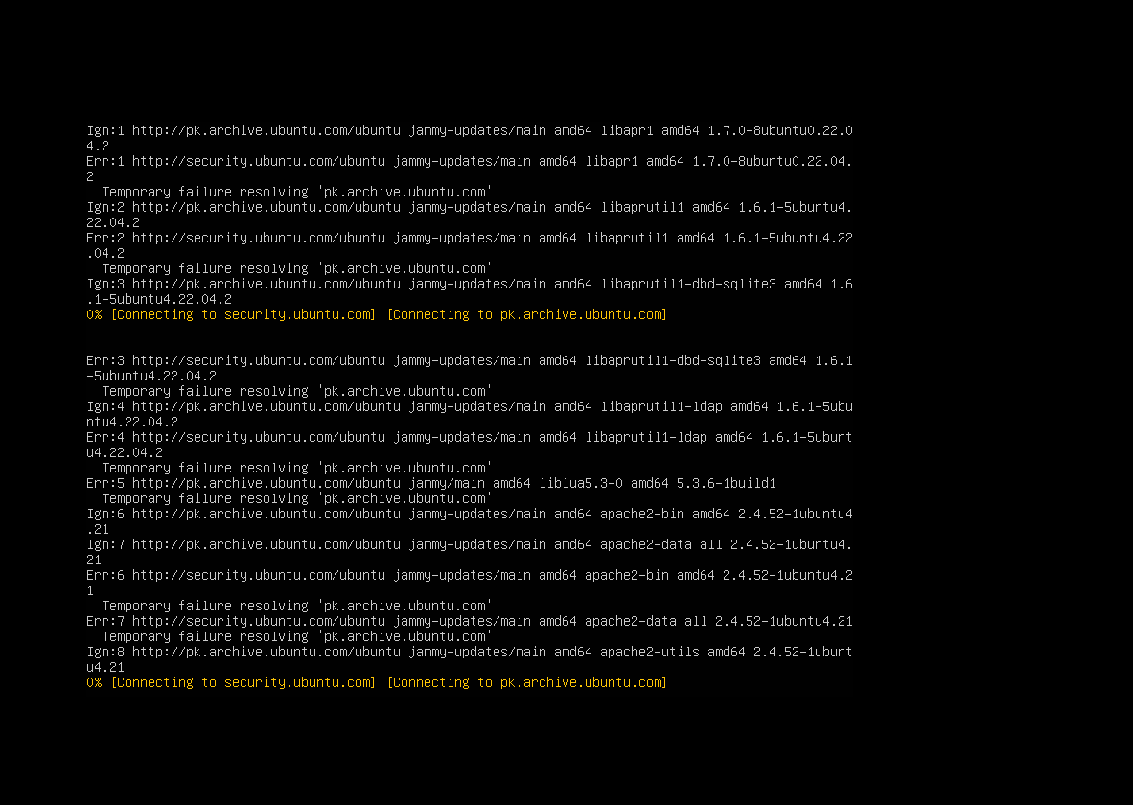

6. Installation and Configuration

Step 1: Install Ubuntu Server
Ubuntu Server was installed on two virtual machines:
- Victim Server
- Snort Server

Screenshot 3: Ubuntu Installation
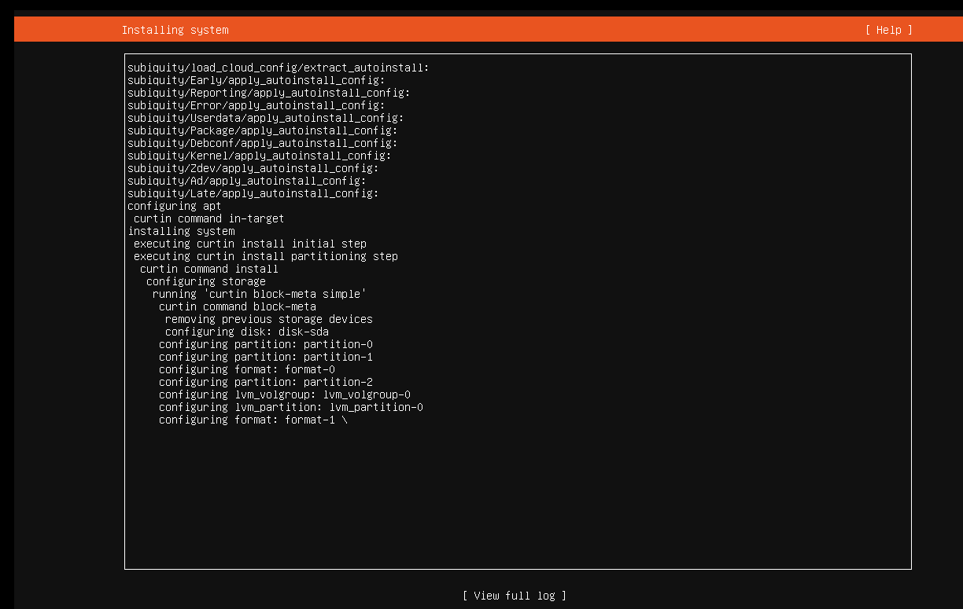

Step 2: Configure Static IP Address
Snort Server
192.168.75.30/24
Victim Server
192.168.75.20/24
Kali Linux
192.168.75.10/24

Screenshot 4:
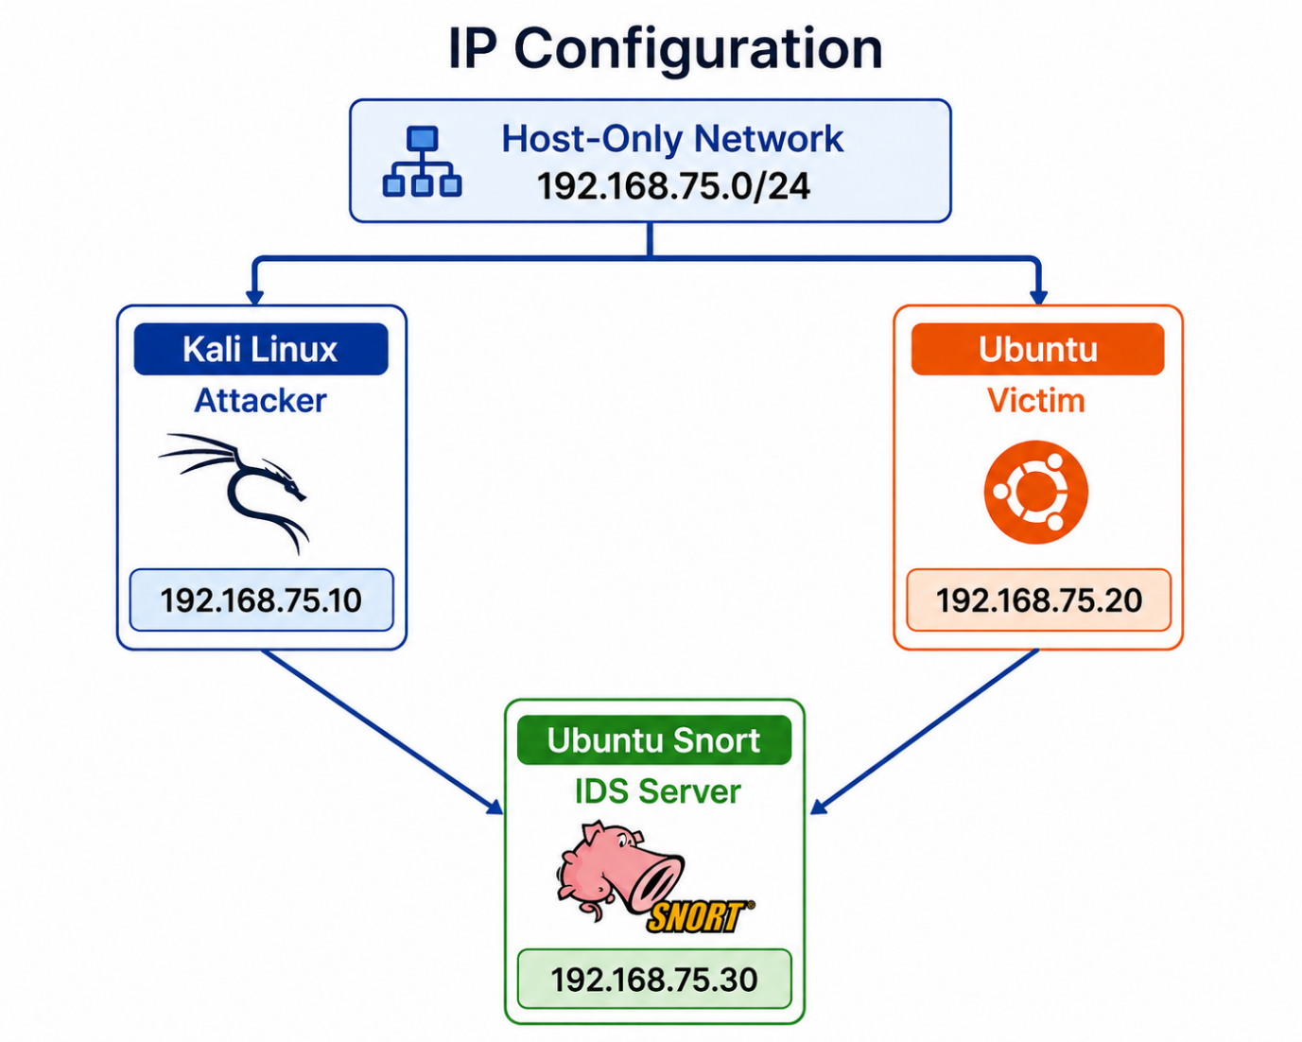

Step 3: Install Snort
Commands:
sudo apt update
sudo apt install snort -y
Verify Installation:
snort -V

Screenshot 5: Snort Version Output
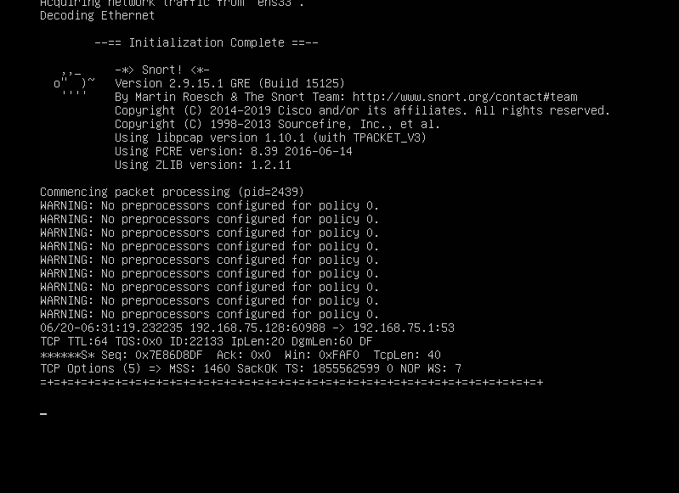

Step 4: Configure Snort
Configuration File:
/etc/snort/snort.conf
Validation:
sudo snort -T -c /etc/snort/snort.conf

Screenshot 6: Snort Configuration Validation
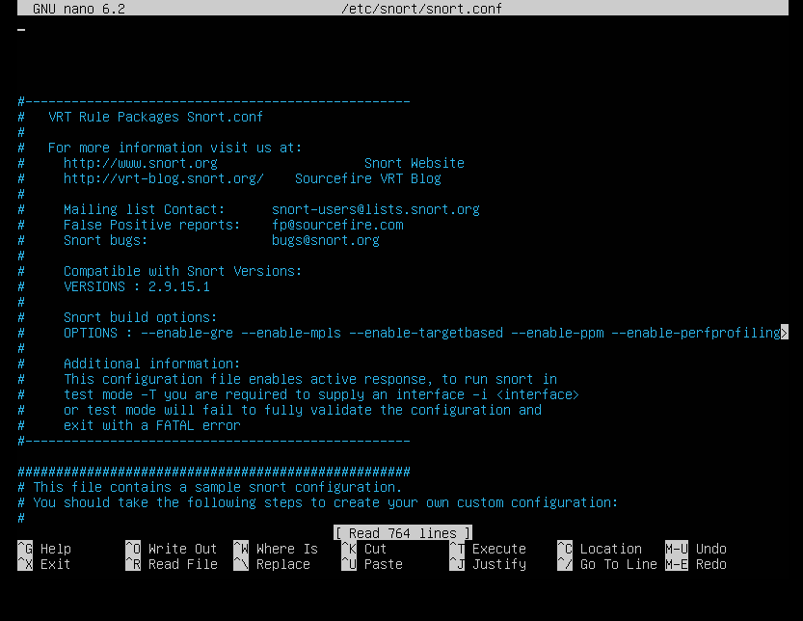

7. Snort Rule Configuration
Custom rules were added in:
/etc/snort/rules/local.rules

Nmap Detection Rule
alert tcp any any -> 192.168.75.0/24 any (msg:"NMAP Scan Detected"; flags:S; sid:500001; rev:1;)

SSH Brute Force Detection Rule
alert tcp any any -> 192.168.75.0/24 22 (msg:"SSH Brute Force Attempt"; detection_filter:track by_src, count 5, seconds 60; sid:5000002; rev:1;)

SQL Injection Detection Rule
alert tcp any any -> 192.168.75.0/24 80 (msg:"SQL Injection Attempt"; content:"' OR"; nocase; sid:5000003; rev:1;)

7. Attack Simulation

Attack 1: Network Scan Detection
Nmap Scan Command:
nmap -sS 192.168.75.20
Purpose:
Detect open ports and services.
Expected Alert:
NMAP Scan Detected

Screenshot 8: Nmap Scan Output
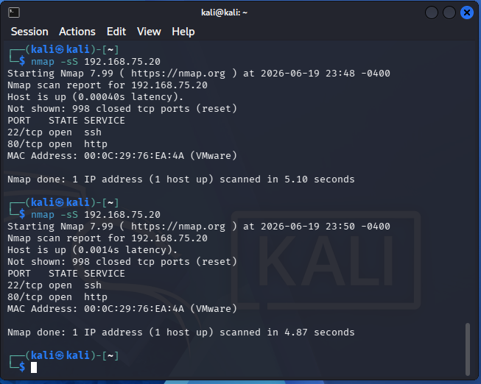

Screenshot 8: Snort Alert for Nmap
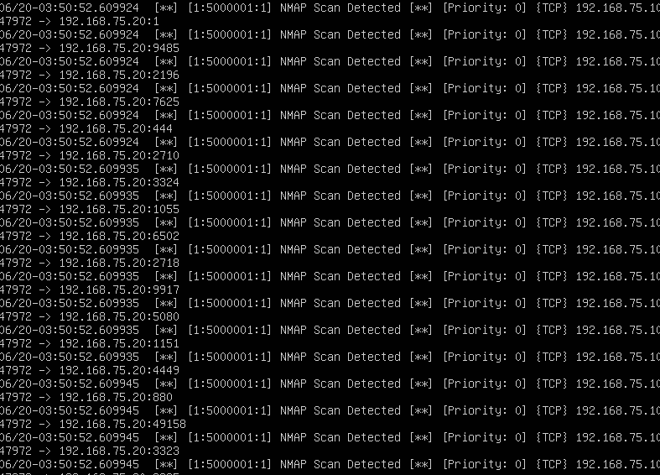

Attack 2: Ping Detection
Command:
ping 192.168.75.30
Purpose:
Generate ICMP traffic.
Expected Alert:
PING DETECTED

Screenshot 9: Ping Attack
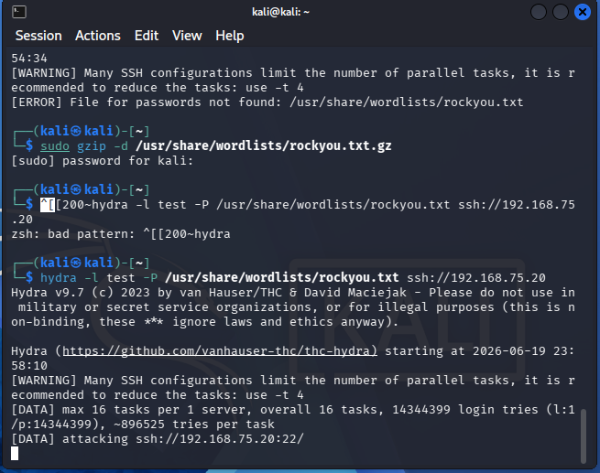

Screenshot 10: Snort ICMP Alert
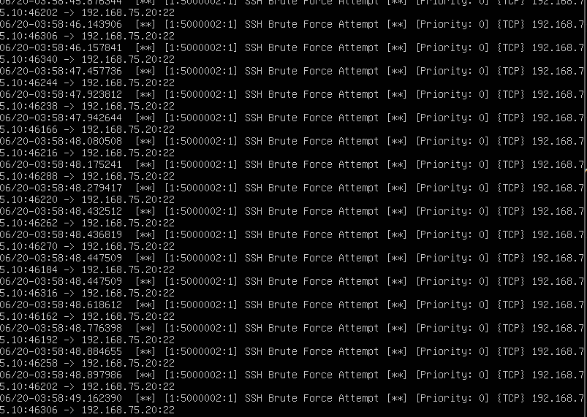

Attack 3: SQL Injection Detection
Command:
curl "http://192.168.75.30/?id=1OR1=1"
Purpose:
Simulate SQL Injection attempt.
Expected Alert:
SQL Injection Attempt

Screenshot 11: SQL Injection Attempt
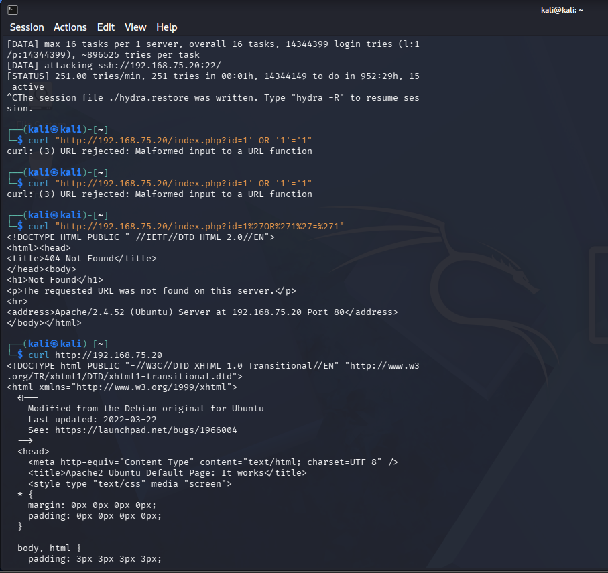

Screenshot 12: SQL Injection Alert

9. Results and Analysis
The Snort IDS successfully monitored network traffic and generated alerts based on custom rules.
Detected Activities:
Attack Type | Status
Nmap Scan | Detected
ICMP Traffic | Detected
SQL Injection Attempt | Detected
The IDS effectively identified suspicious traffic and provided real-time
alerts to the administrator.

10. Conclusion
This project successfully implemented an Intrusion Detection System using Snort in a virtualized environment. The IDS monitored network traffic and detected malicious activities including network scans, ICMP traffic, and SQL injection attempts. The project demonstrates the practical use of intrusion detection systems in strengthening network security.

11. Future Enhancements
Future improvements may include:
- Integration with SIEM platforms.
- Real-time alert notifications via email.
- Detection of advanced persistent threats.
- Machine learning-based anomaly detection.
- Deployment in a cloud environment.

12. References
- Snort Official Documentation
- Ubuntu Server Documentation
- VMware Workstation Documentation
- Nmap Official Documentation
- Hydra Documentation
- Cybersecurity and Network Security Course Material

